**Robotics Club: Lamington Visit**

Welcome.

The following is the list of must-buy things for your bot. you may buy them now or just explore the shops now and buy them later.

**Things to buy:**

1. Chassis base
2. Motors with clamps
3. Wheels
4. A battery (12V Lead Acid)
5. IC 7805 with heat sinks (2)
6. L293D with 16 pin ic holder(2)
7. RF
8. perforated circuit board (pcb)
9. Solder wire
10. A soldering iron
11. A DMM (Digital MultiMeter)
12. Jumper wires (or a long single strand wire, can be cut for use)
13. Berg pins (male and female)
14. Nuts and bolts
15. Double sided tapes (DST)
16. Insulation tapes

This is the list of the essentials that you’d require to build your xlr8 bot. For equipments for customization, you’re to buy them as per requirement.

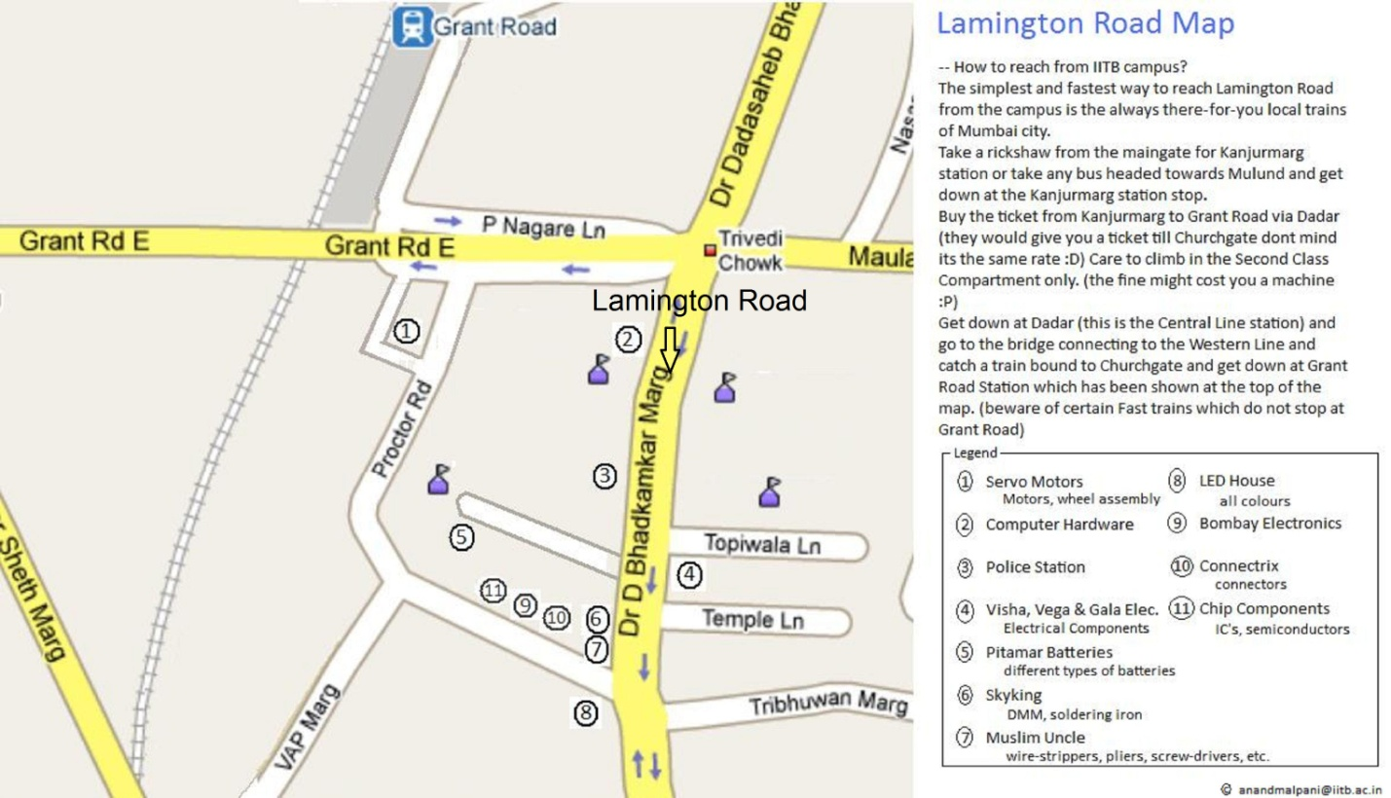**Lamington Road Map**

**For any queries anytime during or after the visit, contact the following:**

|  |  |  |  |
| --- | --- | --- | --- |
| **Manager** |  |  |  |
| Chetan | chetan.agrawal39@gmail.com |  | 9167469004 |
| Vineetha | vinni.iitb@gmail.com |  | 9769470096 |
| **Conveners** |  |  |  |
| Rishabh Chaudhary | choudharyrishabh4@gmail.com |  | 8454041915 |
| Kedar joshi | kedarjoshi7777@gmail.com |  | 9819097671 |
| Madhur Maheshwari | 12madhurmaheshwari@gmail.com |  | 9967352622 |
| Aditya Mate | adityamate22@gmail.com |  | 9892430170 |
| Aishwarya joshi | aishwaryjoshi94@gmail.com |  | 7506122580 |
| Hardik Seth | hardikseth28@gmail.com |  | 9987692500 |
| Rushil Modi | rushilmodi28@gmail.com |  | 9167229212 |
| Maithli Patel | patelmaithili31@gmail.com |  | 9172413114 |